How many closures are occurring and why?
The last couple of years have seen a “wave of charity closures” as impacts of the pandemic continue to be felt alongside a cost-of-living crisis that has put charities under serious and sustained pressure.
Over 168,000 charities appeared on the Charity Commission’s register, as of March 2023. And between March 2023 and January 2024, another 1,000 charities have been registered. The full size of the sector is however, still unknown, as only not-for-profits with a gross annual income of £5,000 or more have to register.
Therefore it’s difficult to know exactly how many extra, unregistered charities there are in the UK. But it’s estimated there are between 80,000 and 100,000 across England and Wales.
Plus, as many as 20,000 organisations that aren't generally regarded as charities also have charitable status in the UK – like private schools, churches, and museums.
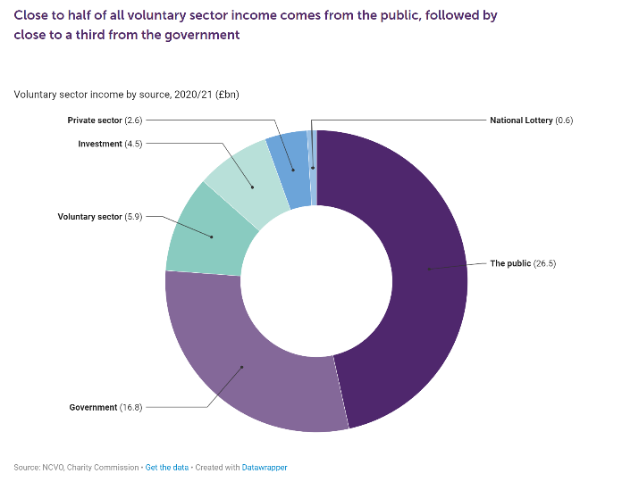
The past few years has not been easy for the sector, with the pandemic followed by the cost of living crisis, and many charities and small organisations are struggling to stay afloat. Funders have noticed the increase in applications and with less money to go about, is it inevitable that some charities will have to close?
NCVO’s report, The Road Ahead 2024, says that “we will continue to see increasing numbers of people seeking to access charity services when they have already been under intense and growing pressure for many years.” And with this “coming so soon after the pandemic, the growing Cost of Giving Crisis means many in the voluntary sector have not had time to look beyond keeping their doors open.”
They go onto say that “the economic outlook will also make public fundraising more challenging – a big issue when the latest figures show public giving makes up almost half of the voluntary sector’s income.
This also comes at a time when less individuals are giving to charity. In CAF’s latest report on charitable giving shows that whilst giving on the whole increased, individual giving is down. They estimate “that 58% of people donated or sponsored in the past 12 months, compared to 59% in 2022 and 65% in 2019, the last year before the Covid-19 pandemic.” And that the “typical (median) donation remained at £20, unchanged for the seventh year in a row, and worth less in real terms due to inflation.”
CAF chief executive Neil Heslop said “it’s concerning that we’re relying on a dwindling group of regular givers, and the typical donation is static and eroded by inflation.” And “that’s why we need to foster a more widespread and sustainable culture of giving to support charities that are squeezed from all sides. Government can set the tone by committing to drawing up a national strategy for philanthropy and charitable giving, ideally as part of a renewed approach to the whole of civil society in every part of the UK.”
This is also the first time they’ve looked at giving by constituency’s so we can see how this looks across London.
In the figure below we can see by looking at the nation’s capitals as a proportion of income, Londoners give the least, while those in Cardiff and Belfast give the most. On average, people in London donate 1.3% of their disposable income to good causes, while in Edinburgh it is slightly higher at 1.8%. Those in Cardiff and Belfast are the most generous, donating 2.1% and 2.5% of their incomes, respectively. However we do know the cost of living crisis has hit Londoners hard, where prices tend to be around 7% higher in London than the UK average and 29% of Londoners, say they are finding it difficult to manage financially this year [2023], up 5% from last year.
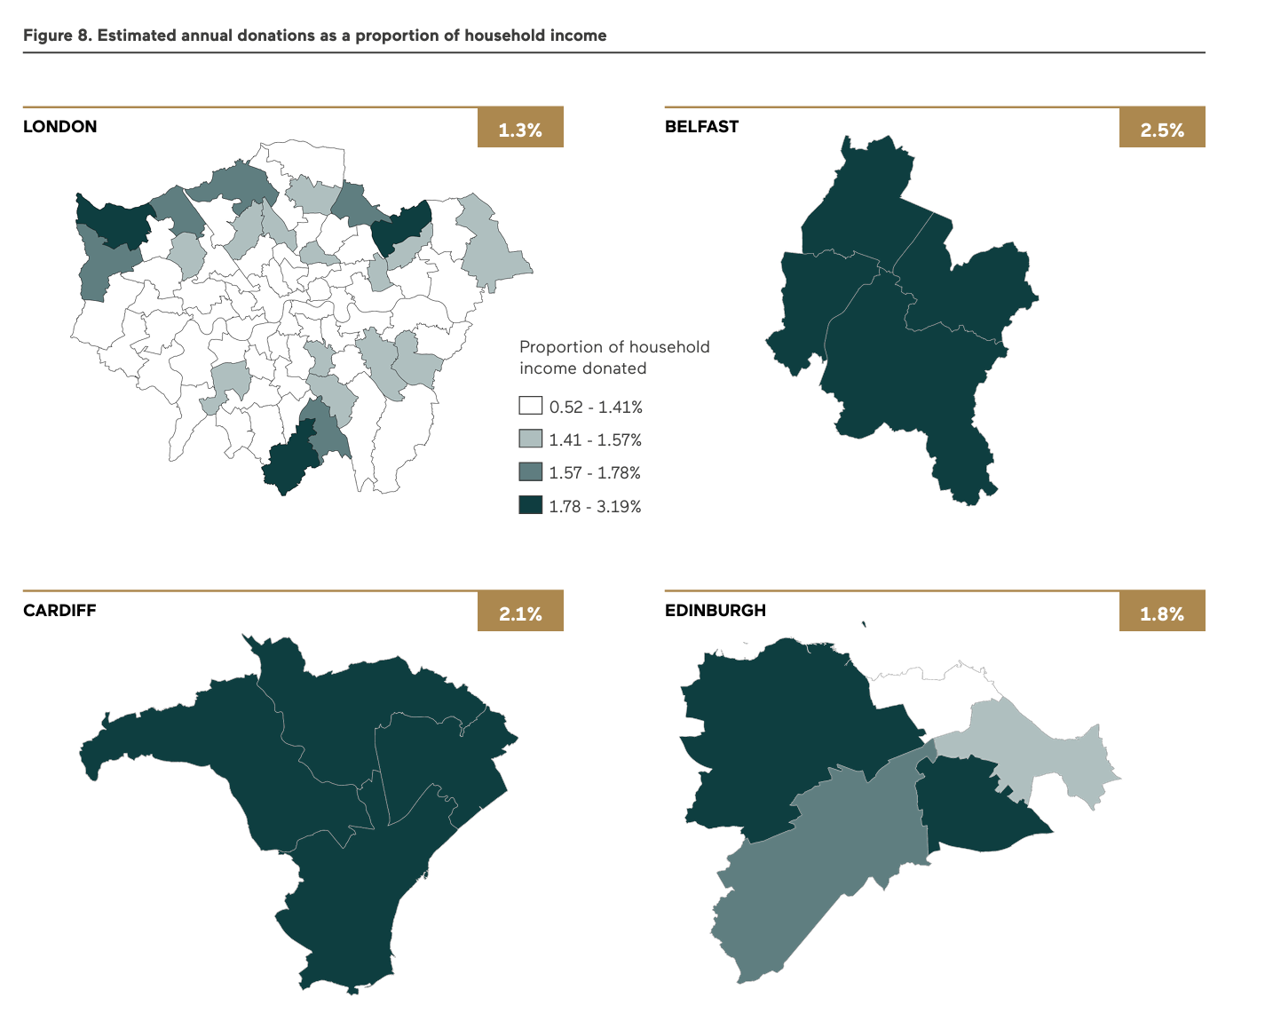
With public services receiving minimal investment and local government facing drastic financial shortfalls under the current government, this vital funding source for the sector will also come under real pressure. In NPC’s State of the Sector 2024: Ready for a reset, they estimate that charities are subsidising government services by £2.4bn every year, and 62% of charities believe that they do not receive the full value it costs to deliver a public sector contract, with the average charity contributing 35% the value of a contract.

NCVO also noted this point to say that “Charities delivering public sector contracts will increasingly have to choose between using charitable funds to make up any shortfall or take the hard decision to withdraw from delivering services. This poses real risks for people who rely on our vital public services - something we must continue to speak out loudly about as a sector.”
Hearing from charities, a detailed NCVO survey of its members “reveals bitterness and frustration among charities who feel their focus on the needs of vulnerable beneficiaries is exploited by public bodies which routinely expect charities not to charge for the full cost of the service or to deliver it for “next to nothing””.
The survey of more than 330 charities found:
- The vast majority were subsidising the cost of providing public services. Nearly half had not received an uplift in the value of the contract in the past two years, despite increasing demand and rising wage and energy costs
- Contracts were often only viable by freezing or cutting staff pay and conditions. One charity made a senior member of staff redundant, then took them back on as a volunteer to do their old job to keep vital services afloat
- A social care charity started a public fundraising campaign, and sold a building it owned, to raise the cash to maintain a service the council would only part fund. “[We are] not sure we can carry on unless something changes,” it said

What can funders do?
Recommendations from CAFs report go directly across three areas; government, donors and charities. For donors they have three clear recommendations:
- Adjust donations for inflation
- Donate to core costs
- Talk to friends and family about giving
And for government they call on them to “deliver a national strategy for philanthropy and charitable giving” to “coordinate activity across government, business, and civil society”.
NPC’s State of the Sector research also set out recommendations to funders and also noting a move to core costs “allows leaders more space to take a step back and think about the longer-term questions about where their organisation is going individually” and that 87% of charities wanted more offers of core funding. Their recommendations are:
- Offer charities funding packages which allow them to reflect and think strategically
- Work with your grantees to understand and meet their needs
- Funders should feel comfortable in funding campaigning as a core part of their grants

Further reading
Carrying out closure, NCVO - https://www.ncvo.org.uk/help-and-guidance/closing-your-charity/carrying-out-closure/
The end of the road: What you need to know about shutting down a charity, Cause4 - https://www.cause4.co.uk/blog/end-road-what-you-need-know-about-shutting-down-charity
Communications guidance on charity closure, ACEVO - https://www.acevo.org.uk/2023/11/communications-guidance-on-charity-closure/
UK Civil society almanac 2023, NCVO - https://www.ncvo.org.uk/news-and-insights/news-index/uk-civil-society-almanac-2023/financials/where-do-voluntary-organisations-get-their-income-from/
What is the true cost of public service delivery, NCVO - https://www.ncvo.org.uk/news-and-insights/news-index/true-cost-of-public-service-delivery/
State of the sector 2024: Read for a reset, NPC - https://www.thinknpc.org/resource-hub/state-sector-2024/
UK Giving, CAF - https://www.cafonline.org/docs/default-source/about-us-research/uk_giving_report_2024_final.pdf?sfvrsn=8ac35647_2

https://data.london.gov.uk/blog/the-rising-cost-of-living-and-its-effects-on-londoners/
https://beta.londoncouncils.gov.uk/news/2023/soaring-cost-living-london-leaves-little-room-breathe

